User Manual

Indigo-imaging Technical CO.,LTD
version 1.3
2021.4

The trademarks and names of the hardware and software products mentioned in this manual are the property of their respective owners.

The copyright of this manual belongs to Indigo-imaging Co., Ltd. All rights reserved. No formal approval of the Company, any organization or individual shall in any means and formats of this manual may be reproduced or transmitted.

The contents of this manual are subject to change without notice.

Copyright © 2016 Indigo-imaging Co., Ltd. All rights reserved.
Tel: 0591-83588265
http: //www.indigo-imaging.com
E-mail: support@indigo-imaging.com
Contents
1 Overview 1
1.1 Manual Instructions 1
1.2 Naming Rules 1
1.3 Packing List 1
1.4 Safety Precautions 2
1.5 Dimensions 2
1.5.1 Camera Dimensions 2
1.5.2 PCB Dimensions 3
1.6 Camera Features 4
1.7 Technical Specifications 5
1.8 Spectral Response 6
1.9 Chip Temperature 7
1.9.1 Working Temperature 7
1.9.2 Relationship between dark current and temperature 7
1.10 Applications 8
2 Physical Interface and I/O Trigger Connector 8
2.1 Camera Interface Functions 8
2.2 The I/O Trigger Pins and Connector Interface Functions 9
2.2.1 The Pins Definition 9
2.2.2 Input / Output Circuit Diagram 9
2.3 Data Output Type 10
3 Camera Feature 11
3.1 Rolling Mode 11
3.2 HDR Mode 11
3.3 sCMOS Sensor 12
3.4 Offset 12
3.5 Exposure Time Setting 12
3.6 Resolution 12
3.7 ROI 12
3.8 Gain Mode 13
3.10 Gamma 13
3.11 Contrast 13
3.12 Sharpen 13
3.13 Filter 13
4 Camera Operation Modes 13
4.1 Free-Mode 14
4.2 Hardware Trigger Mode 14
4.2.1 Normal Level Trigger Mode 14
4.2.2 Normal Synchronous Readout Trigger Mode 14
4.2.3 Global Exposure Level Trigger Mode 15
4.3 Software Trigger Mode 15
4.4 Trigger Acquisition 15
4.4.1 Close Trigger Acquisition Mode 15
4.4.2 I Open Trigger Acquisition Mode 15
4.4.3 Frames Acquisition 15
5 Application Software 15
5.1 Driver Installation 16
5.2 Application Software Introduction 16
5.3 SamplePro 17
5.3.1 SamplePro Introduction 17
5.3.2 SamplePro Window 17
5.4 Camera Control 17
5.4.1 Resolution 18
5.4.2 Language 18
5.4.3 Exposure Time 18
5.4.4 Frame rate 18
5.4.5 Auto Exposure & Target 18
5.5 Image Configure 18
5.5.1 ROI 19
5.5.2 Auto Level 19
5.5.3 Left & Right 19
5.5.4 Gain Mode 19
5.6 File Operation 19
5.6.1 File Format 19
5.6.2 Parameter Save & Load 19
5.6.3 Capture 20
5.6.4 Code & Record 20
5.7 Other Parameters 20
5.7.1 Flip 20
5.7.2 Output Signal 20
5.7.3 Gamma 20
5.7.4 Contrast 20
5.7.5 Sharpen 21
5.7.6 Filter 21
5.8 Trigger 21
5.8.1 Trigger Mode 21
5.8.1.1 Module Introduction 21
5.8.1.2 API Introduction 21
5.8.1.3 Trigger Function Introduction 22
6 Support 23

1 Overview

1.1 Manual Instructions
This manual contains basic information, precautions, camera features, and the user guide of software came with the camera.

1.2 Naming Rules
The Camera model name includes five parts which are separated by delimiter.

S
401
M/C
G/R
H/U/CL
Shutter
Type
Color
Type
Resolution/
Quantum efficient characteristics and product form
Product Identifier
Output
Type

1 2 3 4 5

Figure1-1: Camera model instruction
Each part means:
Table 1-1 Camera model instruction
S | Product Identification
400/401 | “400”stands for 4MP camera, ”401”stands for 4MP camera module
M/C | M: Monochrome C: Color
G/R | G: Global shutter R: Rolling shutter
H/U/CL | H:HDMI output U:USB3.0 output CL: Camera Link output

Note：Product form is determined by mantissa , the mantissa "00" means a camera, if the mantissa "01" means camera model. The table 1-1 takes S-400/401 as an example. Some others use the quantum efficiency characteristic as an identifier，such as S-UV-M-R-U（have response in ultraviolet band）,S-95-M-R-U（quantum efficiency is up to 95 %）.

1.3 Packing List
The whole camera set includes the items as below chart:
Parts | number
Table 1-2 Camera packing list
Please check whether all items are included when get the new cameras. If something is missing or damaged, please contact the after-sale service.

1.4 Safety Precautions
Please read the following safety measure to avoid the incorrect use of the camera which could bring damage to the camera or personal property losses.
①Voltage should be within the standard voltage, otherwise it will cause damage to the camera. In serious cases it can cause a fire.
②Do not touch the plug with wet hands when the camera is working.
③Cut off the power supply if the camera is smoking or smell burning, contact us for maintenance.
④Do not disassemble the camera without non-professional workers, avoid damage to the camera by incorrect operations.
⑤Avoid using this camera in the environment such as the temperature is too high or too low, the humidity is very large, very dusty environment, the sunshine is too strong or a place is surrounded by flammable goods and so on.

1.5 Dimensions

1.5.1 Camera Dimensions
The dimensions of S-UV-M-R-U/HS-95-U3:
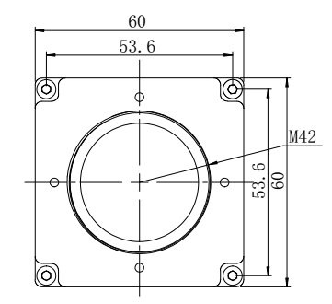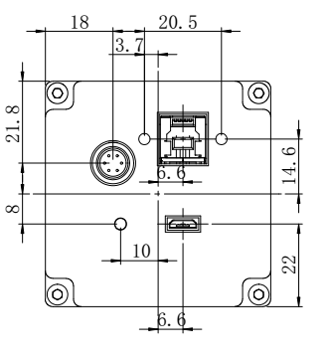
Front view Rear view
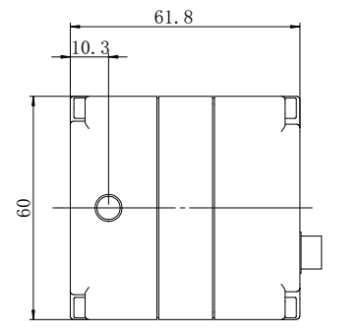
Side view

俯视图

figure 1-2: Dimension of S-UV-M-R-U

The dimensions of HS-200(400)-U3:
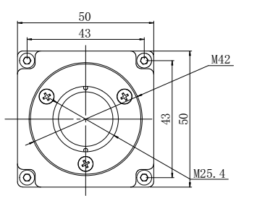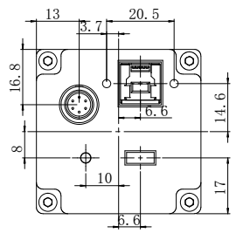
Front view Rear view
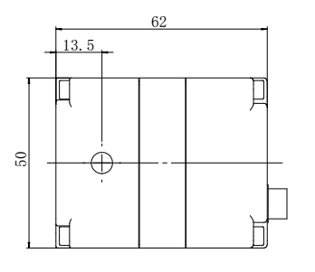
Side view

figure 1-3: Dimension of S-200(400)-M-R-U

1.5.2 PCB Dimensions
There are 3 printed circuit boards: Sensor board, FPGA board and USB board. Figure 1-4 shows the S-UV-M-R-U camera's PCB dimensions and Figure 1-5 shows the S-200(400)-M-R-U camera's PCB dimensions.
The S-UV-M-R-U camera's PCB dimensions:

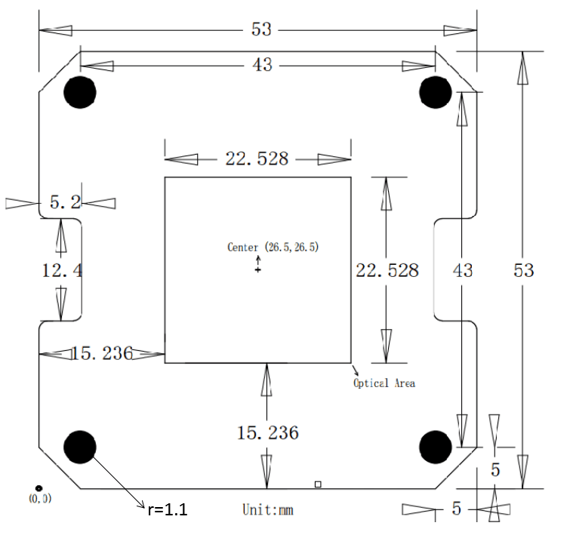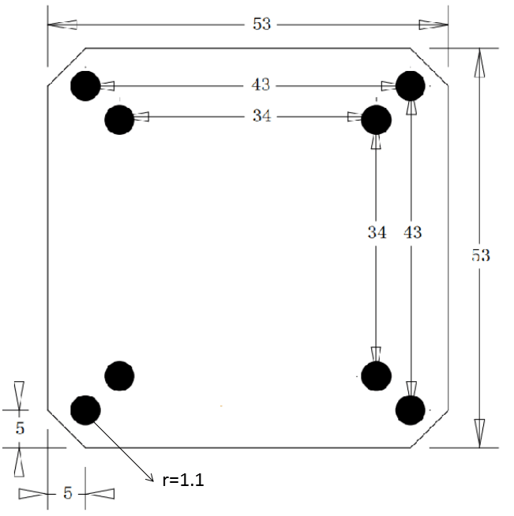
Sensor board FPGA board

USB board

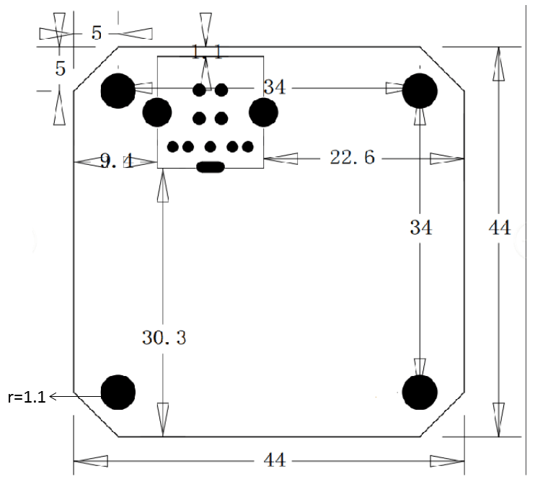

figure 1-4: PCB Dimensions of S-UV-M-R-U/HS-95-U3
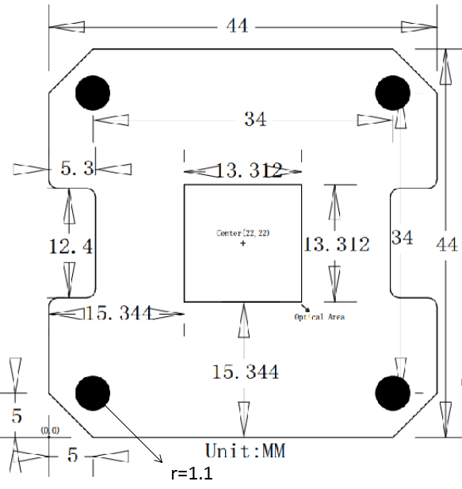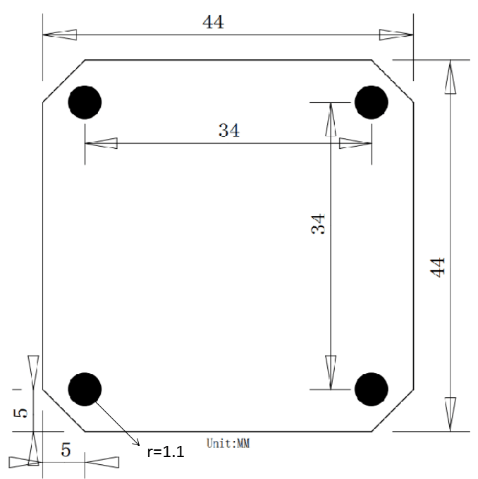
Sensor board FPGA board

USB board

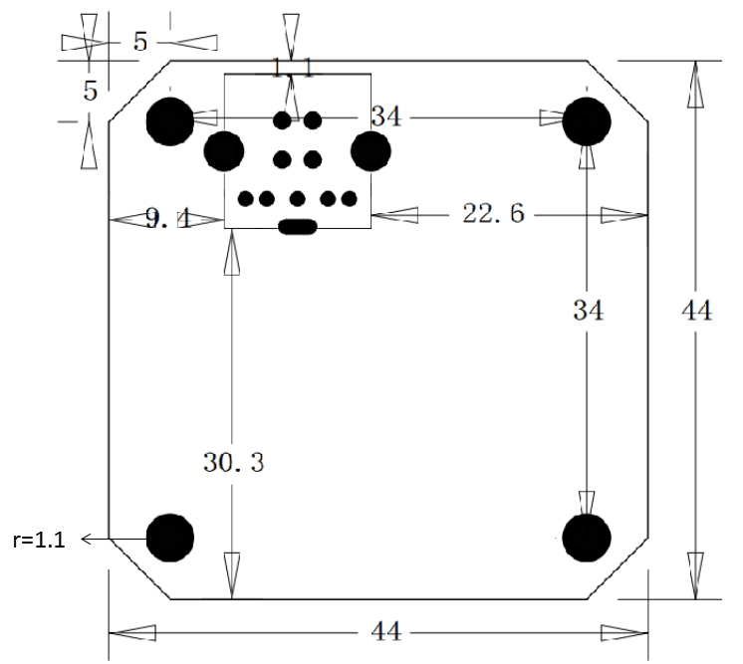

figure 1-5: PCB Dimensions of S-200(400)-M-R-U

1.6 Camera Features
S-UV-M-R-U camera:
2 inch scientific level CMOS image sensor
4MP, 11μmx11μm pixel size
High ultraviolet quantum efficiency（85%@280 nm）
25 fps @ 4MP
USB 3.0 data transfer
Also provide custom digital interface, support further development.
HS-95-U3
2 inch back-illuminated thinned sCMOS chip
95%@580nm ultra-high quantum efficiency
1.6e-Ultra low read noise
2048×2048 resolution
93dB dynamic range
Support multiple trigger function modes
USB3.0 transmission interface
HS-200(400)-U3：
1 inch or 1.2 inch scientific level CMOS image sensor
2MP or 4MP，6.5μm x 6.5μm pixel size
1.8 e⁻ Readout Noise
0.001 lux minimal illumination
High Quantum Efficiency
64 fps@2MP; 36fps@4MP
USB 3.0 data transfer
Also provide custom digital interface, support further development.

1.7 Technical Specifications
Table 1-3 camera technical specifications
Product | S-UV-M-R-U | HS-95-U3 | HS-400-U3
Image Sensor
Sensor Type | Scientific CMOS | Scientific sCMOS | Scientific CMOS
Sensor Size | 2 inch | 2 inch | 1.2 inch
Color Mode | Monochrome | Monochrome | Monochrome
Effective Pixels | 4MP | 4MP | 4MP
Image Resolution | 2048x2048 | 2048x2048 | 2048x2048
Pixels Size | 11μmx11μm | 11μmx11μm | 6.5μmx6.5μm
Camera Parameters
Quantum Efficiency | 84.9 %@280nm | 95%@580nm | 72%@625nm
Readout Noise | 1.3e⁻ | 1.6e- | 1.8e-
Sensitivity Threshold | 3p~ |  | 3p~
Minimal illumination | 0.0001 lux |  | 0.001 lux
Full well Capacity | 100ke⁻ | 100 ke | 48ke⁻
Image Acquisition
Dynamic Range | 93dB | 93dB | 85dB
Shutter Type | Rolling Shutter | Rolling Shutter | Rolling Shutter
Exposure Control
Exposure Mode | Manual | Manual/auto | Manual/auto
Exposure Time | 0.02ms-10 s | 0.02ms-10s | 0.02ms-10s
Image Processing
Settings | ROI、Gamma、Contrast、External trigger、mirror | ROI、Gamma、Contrast、External trigger、mirror | ROI、Gamma、Contrast、External trigger、mirror
Scan Mode | Progressive | Progressive | Progressive
A/D | 16bit | 8bit/16bit | 16bit
Cooling Mode | N/A | N/A | N/A
Preview & Transmission
Frame Rate | 24FPS(2048x2048) | 24 FPS (2048x2048) | 36FPS (2048x2048)
Data Transmission | USB 3.0 (or parallel digital interface) | USB 3.0(or parallel digital interface) | USB 3.0(or parallel digital interface)
Data Cable | USB3.0 cable | 1.8m USB3.0 cable | 1.8m USB3.0 cable
Software&compatible system
PC software | ISCapture | ISCapture/ ImageJ | ISCapture/ImageJ
Compatible system | Windows | Window/Linux/Mac | Window/Linux/Mac
Interface
Optical Interface | EF mount/ T mount/ C mount | C mount | C mount
Data Interface | USB 3.0/5Gb/s | USB3.0/5Gb/s | USB3.0/5Gb/s
Power Interface | USB 3.0 power supply or micro USB auxiliary power supply | USB 3.0 power supply or micro USB auxiliary power supply | USB 3.0 power supply or micro USB auxiliary power supply
Auxiliary Power Interface | Micro USB 2.0 | Micro USB 2.0 | Micro USB 2.0
Dimension | 63 mm x 63 mm x 63 mm | 63 mm x 63 mm x 63 mm | 50 mm x 50 mm x 62 mm
Power Consumer | <2W | <2W | 1.2 W-2.8 W

1.8 Spectral Response
Figure 1-6 shows the quantum efficiency curve of S-UV-M-R-U, the peak QE is 84.9%@280nm.
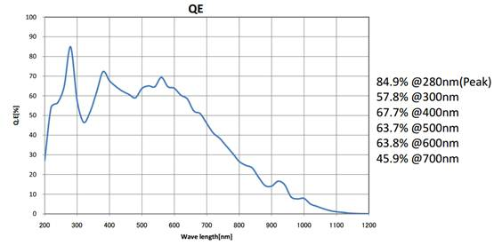
Figure1-6: S-UV-M-R-U QE curve
Figure 1-7 shows the quantum efficiency curve of HS-95-U3, the peak QE is 95%@580nm.
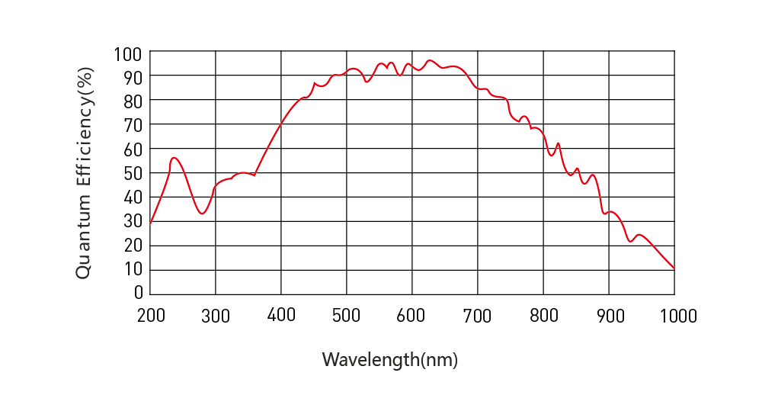
Figure1-7: HS-95-U3 QE curve

Figure 1-8 shows the quantum efficiency curve of HS-200(400)-U3, the peak QE is 80%@625nm.
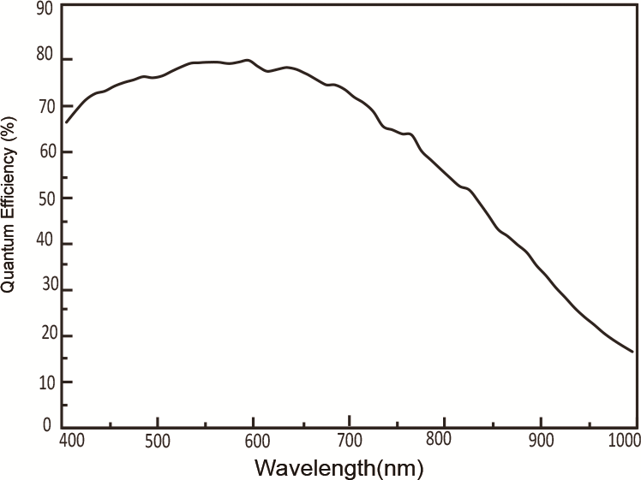
Figure1-8: S-200(400)-M-R-U QE curve

1.9 Chip Temperature

1.9.1 Working Temperature
TBD

1.9.2 Relationship between dark current and temperature
The number of electrons generated by the thermal excitation could be suppressed and the dark current could be reduced by lowering the sensor temperature.
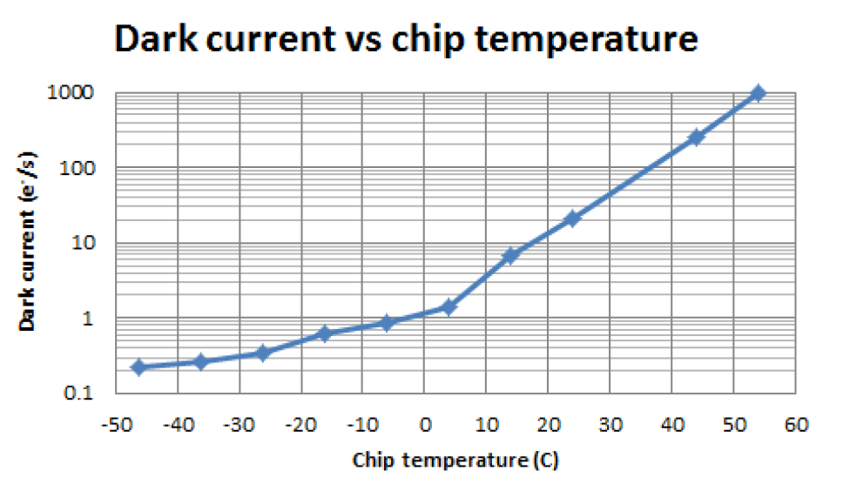
Figure1-9: S-UV-M-R- U Dark Current vs. Chip Temperature Relation Curve

1.10 Applications
S-UV-M-R-U camera application filed:
UV detection, fingerprint analysis, fire warning, tail flame detection.
S-200(400)-M-R-U camera application filed:
Low light night vision, gun aiming, security monitoring etc.

2 Physical Interface and I/O Trigger Connector

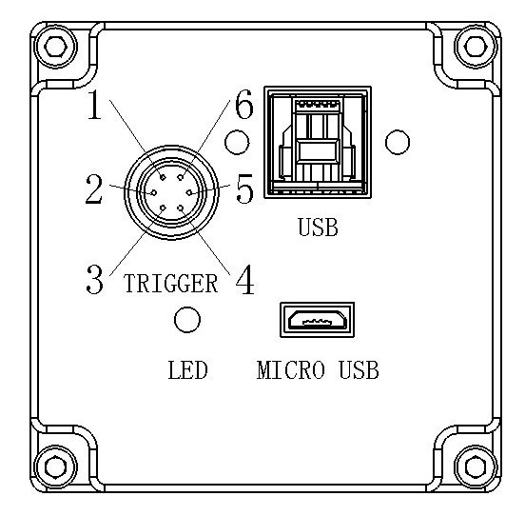
Figure2-1 Camera back view

2.1 Camera Interface Functions
The table 2-1 below shows interface functions:
Table 2-1 The camera interface functions
Part name | Function
TIGGER | External trigger signal input and signal output
USB | For the camera power supply and the data transmission
LED | Power indicator lights, switch on power will be bright.
MICRO USB | Auxiliary power supply(optional)

2.2 The I/O Trigger Pins and Connector Interface Functions

2.2.1 The Pins Definition
As shown in figure 1 trigger interface label, the pin definition is in table 2-2 below:
Table 2-2 trigger connector I/O pin definition
External trigger connector pin number | Pin function and definition
1 | TRI_IN（trigger input）
2 | TRI_GND（GND）
3 | TRI_GND（GND）
4 | TRI_OUT0（Output the exposure indicator）
5 | TRI_OUT1（Indicating signal output alone）
6 | NC

2.2.2 Input / Output Circuit Diagram
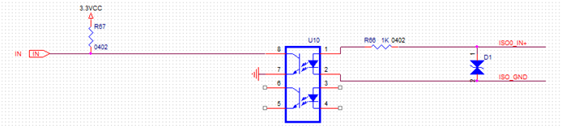
Figure2-2 Trigger light coupling input circuit diagram
Trigger input to the optical coupling circuit voltage in the range of 2.5~30V.
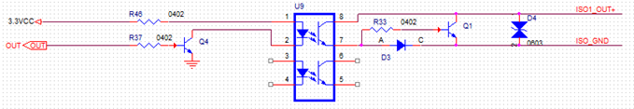
Figure2-3 Trigger light coupling output circuit diagram
Trigger output to the optical coupling circuit voltage in the range of 3.3~30V.
The relationship between the external trigger input pulse, output indication signal and camera exposure timing is shown in Figure 2-4 (with the rising edge level, the standard trigger mode as an example).

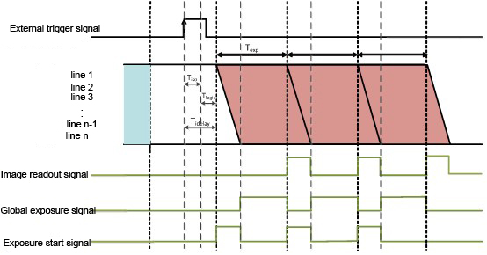
Figure 2-4 Trigger input and output timing diagram
The external trigger level signal through the optocoupler circuit first , and there will be a delay T_{iso} (6 μs ~ 8 μs delay in rising edge input or 40 μs ~ 60 μs delay in falling edge input, which is determined by the characteristics of the optocoupler circuit)
After the optocoupler delay , the input signal to the camera's internal level has a certain logic delay T_{logic} . The value of T_{logic} is 0 ~ 1 minimum exposure unit T_{line}. The minimum exposure unit of the camera is the exposure time of single line T_{line} (14μs ~ 21 μs). Namely the logic delay time range is 0 to 21 μs.
Overall, the total delay of the external trigger input to the start of the exposure T_{idelay} = T_{iso} + T_{logic}.
For three output indication signals, the meanings are as follows:
When the exposure signal is selected, the OUT0 connector will output: the indication level signal of the first line starting exposure to the last line starting exposure.
When the global signal is selected, the OUT1 connector will output: the indication level signal of the last line starting exposure to the first line ending exposure.
When the read signal is selected, the OUT2 connector will be output：the indication level signal of the first line starting readout to the last line starting readout.
These three indicators are always opening by default.
After the three signal output by logic, and then through the optocoupler circuit will have a delay T_{iso} (6 μs ~ 8 μs delay in rising edge input or 40 μs ~ 60 μs delay in falling edge input)

2.3 Data Output Type
A、 The first type: USB3.0 transmission
B、 The second type(customize interface): 40pin, 0.5mm, FPC cable are defined as figure 2-4 shows below.
Consists of parallel TTL digital signal output, I2C control, SPI control, trigger interface.
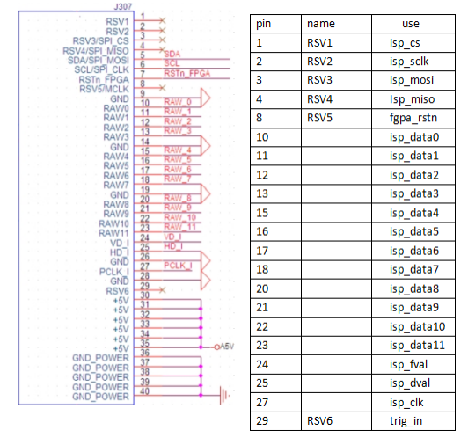
Figure2-4 Signal pin definition
Note：If the signal pin definition is different from left half of the chart, please according to the table.

3 Camera Feature

3.1 Rolling Mode
The first pixel line will be exposed when exposure start signal is received in rolling mode. At the end of the exposure time of first row, each pixel value is output immediately and the second row begins to be exposed. Pixel lines take turns to be exposed and readout from the first row to the last row. Pixel data from sensor is output to build image row by row sequentially. Due to the one line time between each row, exposure length is same but exposure timing is different for all lines.

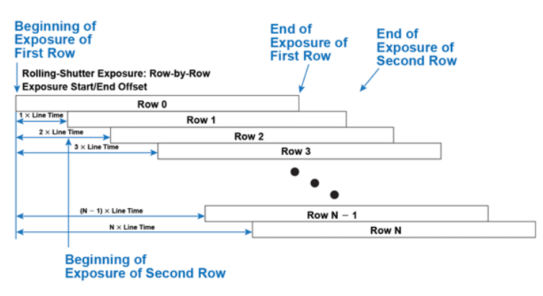
Figure3-1 Row operation in rolling shutter

For its feature of progressive scanning , rolling shutter camera is suitable for capturing static object but not the high speed moving object.

3.2 HDR Mode
Image signals are readout from the HG channel and LG channel simultaneously from both bottom and top side of the sensor line by line, a high dynamic range image can be constructed by the low gain image and high gain image for HDR mode.

3.3 sCMOS Sensor
Indigo-imaging camera is based on scientific CMOS image sensor, featured with very low readout noise and high frame rate. These features make Indigo-imaging camera an ideal camera for various applications.

3.4 Offset
The camera has noise and electron when working in complete dark condition. The noise and electron need to be subtracted because they will be found and considered as valuable signal.

3.5 Exposure Time Setting
The value of exposure time is set by software or external trigger.

3.6 Resolution
The full resolution of camera is 2048x2048(1x1 bin, bin means pixel binning). The 1x2 bin resolution is 2048x1024, for two of vertical pixels are merged into one pixel. The 2x1 bin resolution is 1024x2048, for two of horizontal pixels are merged into one pixel. The 2x2 bin resolution is 1024x1024, for four of vertical and horizontal pixels are merged into one pixel.
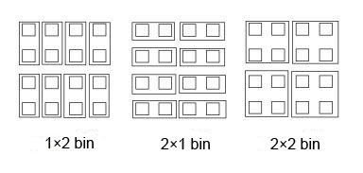
Figure3-2 Pixel binning diagram

3.7 ROI
Define an interested area within the scope of the camera sensor resolution to read out the image information and get the image of local area only. The Region of Interest (ROI) control allows users to operate at higher frame rates by placing a lower resolution “window” on the image at any location.

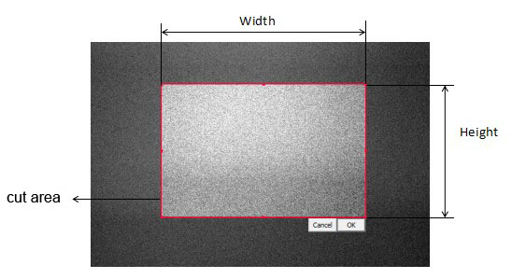
Figure3-3 ROI operation

3.8 Gain Mode
The camera has three working modes;
High Gain: High sensitivity mode, which is suit for ultra-low light detection;
Low Gain: High full-well capacity mode, which can detect maximum photon;
HDR: High dynamic range, which can detect ultra-low light and strong light signal simultaneously.
3.9 Signal Output
Output signal is used to output level signal for the user guidance, and the followings show the connection of the trigger interface pin:
Pin ISO 0 output exposure signal
Pin ISO 1 output readout signal

3.10 Gamma
Gamma is used to obtain correct reproduction of intensity.

3.11 Contrast
Contrast is the difference between the brightness bright and the darkest darks in an image. Higher contrast will make the shadows become darker and the highlights brighter. High contrast will lost more image details.

3.12 Sharpen
Sharpness is the contrast on the edge. Sharpening can help to get sharper images and see more image details by increasing the bright and dark lines on edges.

3.13 Filter
Each image has noise and the noise has great effect on the quality of image. Filter is used to reduce noise for the noise cannot be undo .
The filter, namely 2D median noise reduction, can remove acnode noise without breaking the image edge features. It's effective to filter out pulse interference and scan image noise.

4 Camera Operation Modes
The camera's operating modes are Free Mode, Hardware-Triggered, and Software-Triggered.

4.1 Free-Mode
In free running mode, the camera is reading out and uploading the data continuously. Give a snapping signal, the camera will grab part of uploading data, which may contain incomplete image frame.

4.2 Hardware Trigger Mode
There are three types of camera hardware trigger modes:
①Normal level trigger mode
②Normal synchronous readout trigger mode
③Global exposure level trigger mode .

4.2.1 Normal Level Trigger Mode
Normal level trigger means that the control of beginning to exposure is set by the falling or raising edge of the signal level and the length of exposure time is determined by the duration of level. This mode does not shoot continuously because of the trigger ready output, commonly used for capturing images of stationary and slow moving objects.
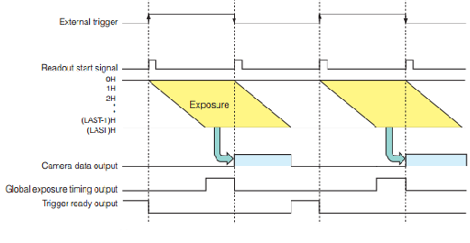
Figure4-1 Normal level trigger

4.2.2 Normal Synchronous Readout Trigger Mode
Synchronous trigger read out is the exposure of each frame of the camera are subject to external trigger source control, that is synchronous read trigger time is determined by the external trigger, the camera's read and the next exposure is synchronized.
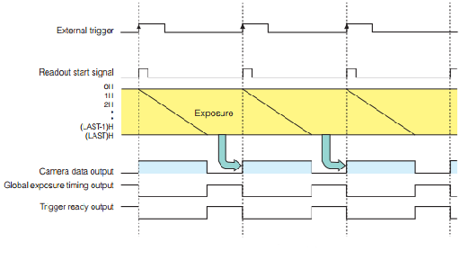
Figure4-2 Normal synchronous readout trigger

4.2.3 Global Exposure Level Trigger Mode
Global exposure level trigger has four characteristics:
1) The camera is pre-exposed, but not scanned.
2) The light source triggers the camera to begin exposure, and the lighting phase must ensure that all lines are in the exposure phase.
3) Exposure time is determined by the level width, and the output data consists of 2 successive frames.
4) It is not a continuous shooting mode.
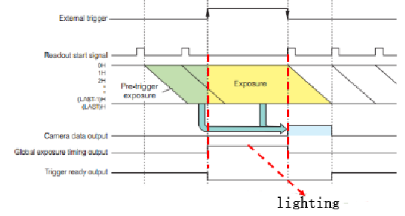
Figure4-3 Global exposure level trigger

4.3 Software Trigger Mode
Set the camera in the software mode, give the camera a snap signal, the camera will capture an image with a full frame from the memory block.

4.4 Trigger Acquisition

4.4.1 Close Trigger Acquisition Mode
When the trigger acquisition mode is set to off, there is no need to request to trigger the acquisition signal, the camera will generate by its own internal.

4.4.2 I Open Trigger Acquisition Mode
When Trigger Acquisition Mode is set to open, the camera is waiting for the acquisition to begin. A start trigger signal must be requested to allow the camera to exit the waiting and begin acquisition state and enter the acquisition state waiting frame start trigger before the camera can begin frame acquisition.

4.4.3 Frames Acquisition
If the trigger acquisition mode is set to on, you need to set the number of frames to capture. The number of acquired frames can be set between 1 and 255.

5 Application Software
SamplePro is excellent software for camera control, image acquisition and archiving of images in various file formats. This chapter provides a detailed description of all SamplePro functions.

5.1 Driver Installation
To use the Indigo-imaging camera, you need to install the camera driver and SimplePro application software first.
Step1. Find the file “Indigo-imaging Camera Driver " Setup.exe" from the CD, double-click on it to start the installation and hit “Next”.
Step2. Follow the steps to finish the installation.
NOTE：Please go to the Device Manager to check if the driver was installed properly. When the driver is installed correctly, there is no yellow mark with the camera under the Imaging Device in Device Manager.

5.2 Application Software Introduction
The SamplePro windows application software enables you to control every camera parameter or setting. Image can be displayed on a monitor and may be stored. The table below lists the key functions of SamplePro.
Application Software |  | SamplePro
Function Menu |  | Introduction
Camera Control | Preview | Start the program and display the live images in the window
Camera Control | Resolution | Select resolution for live image and capturing
Camera Control | Language | Chinese or English
Camera Control | Exposure Time | Adjust the exposure time manually
Camera Control | Frame rate | Display the current frame rate
Camera Control | Auto Exposure & Target | Check the "Auto Exposure" check box to adjust exposure time automatically
Image Configure | ROI | Place a lower resolution “window” on the image at any location
Image Configure | Auto Level | Turn on/off the auto level function
Image Configure | Left | Lower limit of the level displayed
Image Configure | Right | Upper limit of the level displayed
Image Configure | Gain Mode | Select the working gain mode：high gain, low gain, HDR
File Operation | File Save | Select the format of images：jpg, tiff, png or raw
File Operation | Parameter Save & Load | Save the current parameter settings or load the saved parameter settings
File Operation | Capture | Capture the image
File Operation | Code & Record | start/ stop video recording
Other Parameters | Flip | Check and make the image flip
Other Parameters | Output Signal | Turn on/off signal output
Other Parameters | Gama | Set the gamma value
Other Parameters | Contrast | Set the contrast value
Other Parameters | Sharpen | Set the sharpness value
Other Parameters | Filter | Turn on/off the filter function
Trigger | Hardware | Select the external hardware trigger mode
Trigger | Exposure | Select exposure time mode
Trigger | Edge | Select activation edge
Trigger | Frames | Adjust the frames per capturing
Trigger | Delays | Adjust the delay time to trigger exposure
Trigger | Apply | Make the trigger mode that is choose working
Trigger | Software-On | Turn on/off the software trigger function
Table 5-1 SamplePro function list

5.3 SamplePro

5.3.1 SamplePro Introduction
SamplePro is used to obtain and process pixel date from Indigo-imaging camera. It consists of live image window and picture processing module. User can control the camera easily by SamplePro.

5.3.2 SamplePro Window
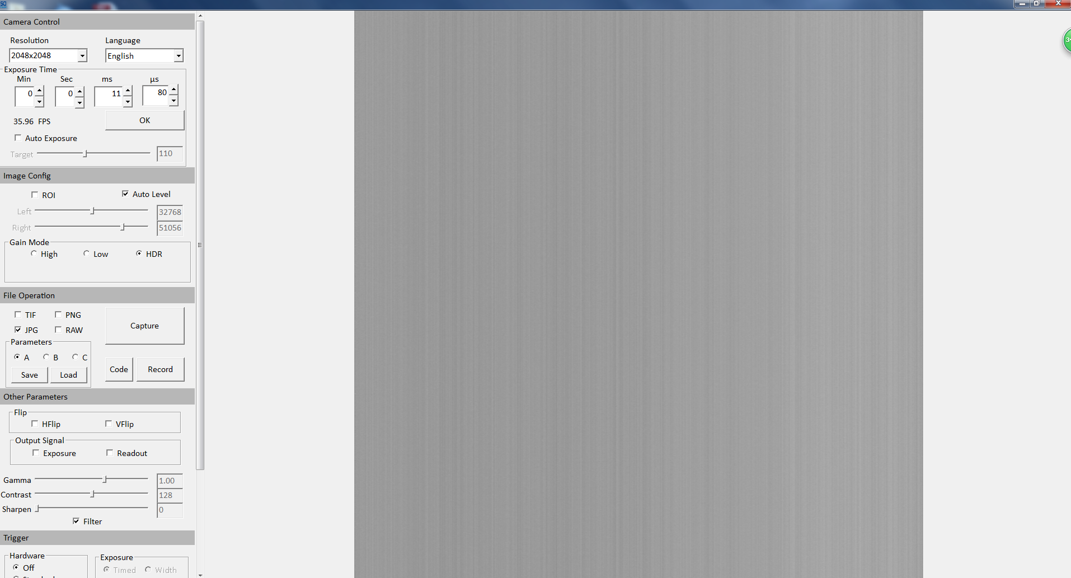
Figure5-1 Software window
Figure5-1 shows the interface of SamplePro, the left is menu bar and the right is live image window.

5.4 Camera Control
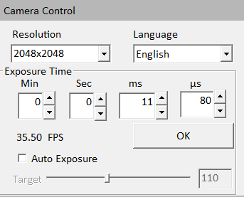
Figure5-2 Camera control menu

5.4.1 Resolution
Adjust the resolution of image.

5.4.2 Language
Select the displayed language for software: Chinese (simplified), English.

5.4.3 Exposure Time
Adjust the exposure time manually. Key the exposure time in the edit box directly, then click "OK" to confirm it.

5.4.4 Frame rate
Display the current frame rate.

5.4.5 Auto Exposure & Target
Check [Auto Exposure] checkbox, software start to adjust the exposure time automatically to get proper brightness of live image.
Auto exposure target value: Set the reference exposure time for auto exposure adjustment. The default 110 is recommended. It helps the auto exposure to find the proper exposure time faster. For example, if the imaging target is quite bright, a lower target value is set, it will indicate a shorter exposure time to the software.

5.5 Image Configure
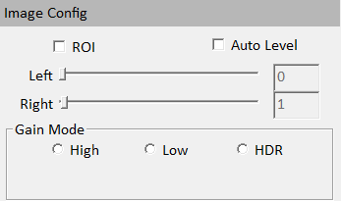
Figure5-3 Image configure

5.5.1 ROI
It is used to set the interested areas of image, with the upper left corner as the origin of coordinates.

5.5.2 Auto Level
Check the "Auto Level" checkbox: adjust the live image levels automatically.

5.5.3 Left & Right
Left: It is used to set the black point or shadow values. Move the Left Point Slider towards right to darken the shadow areas in the image. It will reveal bright area information.
Right: It is used to set the white point or shadow values. Move the Right Point Slider towards left to brighten the highlights in the image. It is able to reveal some information in dark area.

5.5.4 Gain Mode
The camera's working modes are divided into the following 3 categories: high gain, low gain and HDR.

5.6 File Operation
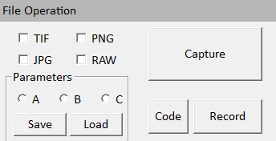
Figure5-4 File operation menu

5.6.1 File Format
Four file formats are available: TIF,PNG,JPG and RAW. JPG is the default format.
NOTE: Raw and tiff image file contains minimally processed data from the camera. It needs to be read in some special software for example Photoshop, ImageJ etc.

5.6.2 Parameter Save & Load
Save: save the current parameters information to item A, B or C .
Load: load the setting parameters to current image from item A, B or C.
Item A/B/C is used to keep the parameters setting, just like the text file.

5.6.3 Capture
Capture the image with current parameter settings.

5.6.4 Code & Record
Click "Record", start/ stop video recording.
Click [Code] to list all the available video compressors on the PC.
NOTE: The video taken without any compression will be very large size.

5.7 Other Parameters
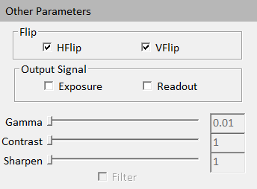
Figure5-5 Other parameters menu

5.7.1 Flip
Check the "HFlip" checkbox to make the image flip horizontally.
Check the "VFlip" checkbox to make the image flip vertically.

5.7.2 Output Signal
Check the "Exposure", one trigger interface will output : the indication level signal of the first line starting exposure to the last line starting exposure.
Check the "Readout", another trigger interface will output: the indication level signal of the first line starting readout to the last line starting readout.

5.7.3 Gamma
Adjust image gamma, the range is 0.2 to 1.5 and 1.0 is default. Gamma is used to obtain correct reproduction of intensity.

5.7.4 Contrast
Adjust Contrast. The range is 0-255 and 128 is default. Contrast is the difference between the brightness brights and the darkest darks in a image. Increase the contrast, the shadows become darker and the highlights brighter. Decrease the contrast, the highlights grow dim and the dark areas lighten up.

5.7.5 Sharpen
Adjust the image sharpness.

5.7.6 Filter
Check the "Filter" checkbox to open the filter function. Opening is default setting.

5.8 Trigger

5.8.1 Trigger Mode
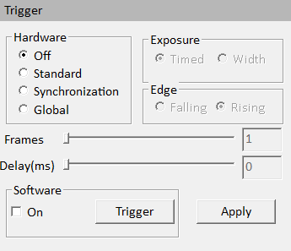
Figure5-6 Trigger menu

5.8.1.1 Module Introduction
Camera capture modes are divided into the following 2 categories:
Sequence mode (stream mode): it is used to capture continuous image data.
Trigger mode: the camera captures the images by the external signals.
Trigger Mode:
1. Standard Mode, the parameters of exp/edge/delay/frames are supported.
2. Synchronization Mode, namely the synchronous picture grabbing, only the parameter of edge is supported.
3. Global Mode, used to control the CMOS camera of shutter exposure mode to achieve global exposure mode like CCD, generally used for the scenes of controllable light source.
4. Software Trigger Mode: send commands to simulate trigger signal by software.

5.8.1.2 API Introduction
1Typedefs
enum {
DEVICE_STREAM = 0x0001,
DEVICE_HW_STANDARD = 0x0002,
DEVICE_HW_SYNC,
DEVICE_HW_GLOBAL,
DEVICE_SW_TRI, // software trigger
DEVICE_RESEVER ,
};
2 function declaration
SetTrigger(int mode, int exp, int edge, int delay, int frames, const char *devName);
GetTrigger(int *pMode, int *pExp, int *pEdge, int *pDelay, int *pFrame, const char *devName);
SetGpio(int index, bool state, const char *devName);
3 parameters explanation
mode: 0~3,hardware[send command by hardware]，4 software [send command by SetGpio()]
datamode,0 standard steam mode [hardware],all of the trigger parameters are not supported.
datamode,1 standard trigger mode [hardware],all of the trigger parameters are supported.
datamode,2 Synchronization trigger mode [hardware],only edgetype is supported.
datamode,3 Global trigger mode [hardware],exptype and edgetype are supported.
datamode,4 Synchronization trigger mode [software], all of the trigger parameters are not supported, send command by SetGpio().
exptype: exposure type 0：timed，1：level width
edgetype: 0:rising edge,1:falling edge
delaytime：the delay time to exposure, the unit is ms.
frames： The number of captured frames

5.8.1.3 Trigger Function Introduction
0) Closing ：
Call SetTrigger(0, x, x, x, x,pName) into DEVICE_STREAM mode , means trigger mode is closed. The camera captures continuous image data.
When choosing "Standard"," Synchronization" or "Global", the camera switches to trigger mode. The camera only captures image data after receiving a trigger signal.
Attention：the camera will capture images if input level signal is received even then the trigger mode is closed. This is a special design in the camera.
- Standard Mode：
Call SetTrigger(1, x, x, x, x,pName) into DEVICE_HW_STANDARD mode;
Standard Mode consists of the following configurations:
A. Exposure time:
Timed: after receiving the trigger signal, it is determined by the exposure time set by the software.
Trigger Width: after receiving the trigger signal, the exposure time is determined by the level width.
B. Activation Edge
Rising Edge: means the trigger signal is rising edge valid
Falling Edge: means the trigger signal is falling edge valid
C. Number of frames
It means after receiving a trigger signal, the exposure time of each image is the same no matter how many images are shot, which depends on the software settings. (When choosing level width, the function is invalid.)
D. Delay
It means after receiving a trigger signal, the delay time of the desired delay time can be set to trigger the camera exposure .
- Synchronization Mode：
Call SetTrigger(2, x, x, x, x,pName) into DEVICE_HW_SYNC mode;
Namely the synchronous picture grabbing, first trigger to start, and the second trigger to output synchronization image.
Synchronization mode has one configuration only, for the exposure time is set by the input level width. Activation Edge：
Rising Edge: means the trigger signal is rising edge valid.
Falling Edge: means the trigger signal is falling edge valid.
3）Global Mode：
Call SetTrigger(3, x, x, x, x,pName) into DEVICE_HW_GLOBAL mode;
A method that uses the rolling shutter readout mode with a slightly expanded exposure time, resulting in a slice of time during which all the lines of the sensor are being exposed simultaneously
Global mode consists of 2 configurations:
A. Exposure time:
Timed: means the exposure time is set by the software
Trigger Width: means the exposure time is set by the input level width
B. Activation Edge
Rising Edge: means the trigger signal is rising edge valid
Falling Edge: means the trigger signal is falling edge valid
4）Software Trigger：
Simulate trigger signal via the software command.
Call SetTrigger(4, x, x, x, x,pName) into DEVICE_SW_TRI mode.
Click "snap" to capture images by sending command to camera . (send SetGpio(0, true,camName));
NOTE：Click "Apply" bottom to confirm your setting when the parameters of mode/exp/edge/delay/frames is changed.

6 Support
You can also get support in the following ways:
- Web Support - Visit www.indigo-imaging.com for documentation and technical support.
- Hotline Support - Contact us via hotline 086-0591-28055076
- E-mail support - Send feedback to support@indigo-imaging.com, our technical staff will reply in time.

